😶‍🌫️ Report Outline
Deliverables | Segmentation | Dutch Bros Coffee

Report Sections:
- Cover Page - Cindy Completed
- Table of Contents - Cindy In Progress
- Background & Research Objectives - Samantha In Progress
- Research Method - Jade Not Started
- Findings & Marketing Insights (with charts and cluster profiles) | 2 people - Amisha, Khush In Progress
- Recommendations - Alanna Not Started
- References - Everyone Not Started
- Appendix (Survey Questionnaire) - Cindy Completed

Presentation (12–15 min): MKTG 612
- Introductions Completed
- Problem statement - Samantha Completed
- Method & data Not Started
- Cluster results & perceptual map | 2 people Not Started
- Strategy recommendations - Alanna Not Started
- Ending statements In Progress

Cover page
| Sample cover page will be provided on Canvas including project title, course title, group
members, contribution of each group member, due date of project. |

Table of content

Main content
- Background and research objectives (1 page)
  - Specify the background information of the chosen marketing problem. Identify research objectives based on the stated problem.
- Research method (0.5 page)
  - What method will be used to conduct the research? Describe the sample method and sample size (40-60) in detail. And briefly discuss the limitation of the research.
- Findings and marketing insights (4-6 pages)
  - Analyze the data using models/ methods in Enginius and display the results. Discuss the major findings from data analysis in detail with the relevant output. Based on the findings, what marketing strategies do you recommend to solve the stated problem?
  - Include the following issues in your data analysis:
    - Segmentation & Targeting
      - Identify segmentation variables and discriminant variables.
      - Segmentation analysis: Identify number of clusters and name each cluster; which clusters would you target for your market campaign?
      - Discriminant analysis: Describe each segment.
- Recommendations and strategy (1 page?)
  - What will we do with our findings
  - Next steps? - based on data
- Appendix
  - e.g., Questionnaire
- References - Everyone

❓ Questionare

Dutch Bros Coffee – Marketing Segmentation Questionnaire
Q0 This study aims to understand customer experiences, preferences, and habits to help improve Dutch Bros’ products, service, and marketing strategies. Your responses are confidential and will be used only for research purposes. Thank you for sharing your time and honest feedback!
Survey link


Q1 How often do you purchase coffee or similar beverages from a café or drive-thru?
o Daily (1)
o Several times per week (2)
o Once a week (3)
o 1–3 times per month (4)
o Never (5)
Skip To: Q15 If Q3 = Never

Q2 Which of the following coffee brands have you purchased from in the past month? (Select all that apply)
▢ Dutch Bros Coffee (1)
▢ Starbucks (2)
▢ Peet’s Coffee (3)
▢ Dunkin’ (4)
▢ Local independent coffee shops (5)
▢ Other (specify ______) (6) ___________________________

Q3 How long have you been a Dutch Bros customer?
o Less than 6 months (1)
o 6 months – 1 year (2)
o 1–3 years (3)
o 3+ years (4)
o I haven’t tried Dutch Bros yet (5)
Skip To: End of Survey If Q3 = I haven’t tried Dutch Bros yet

Q4 On average, how often do you visit a Dutch Bros location?
o Daily (1)
o Several times per week (2)
o A few times per month (3)
o Less than once a month (4)

Q5 What time of day do you typically visit Dutch Bros? (Select all that apply)
▢ Morning (6 a.m.–10 a.m.) (1)
▢ Midday (10 a.m.–2 p.m.) (2)
▢ Afternoon (2 p.m.–6 p.m.) (3)
▢ Evening (6 p.m.–10 p.m.) (4)

Q6 What types of beverages do you typically purchase? (Select all that apply)
▢ Iced coffee drinks (1)
▢ Hot coffee drinks (2)
▢ Blended drinks (Freeze, Frost etc.) (3)
▢ Energy drinks (Rebel line) (4)
▢ Tea / Lemonade / Other non-coffee drinks (5)

Q7 How much do you typically spend per visit at Dutch Bros?
▢ Under $5 (1)
▢ $5–$9 (2)
▢ $10–$14 (3)
▢ $15 or more (4)

Q8 How do you usually make your purchase?
▢ Drive-thru (1)
▢ Walk-up window (2)
▢ Mobile app order (3)
▢ Delivery service (4)
▢ Other (specify ______) (5)

Q9 Please indicate how strongly you agree with each statement (1 = Strongly Disagree to 5 = Strongly Agree):
 | Strongly Disagree | Somewhat disagree | Neither agree nor disagree | Somewhat agree | Strongly agree

 | 0 | 1 | 2 | 3 | 4 | 5

I see coffee as a key part of my daily routine. () | 
I prefer brands that promote a fun, positive, and energetic culture. ()
Supporting community-focused or local brands is important to me. ()
I’m willing to pay more for unique flavor combinations. ()
I often share my coffee experiences on social media. ()
I prefer personalized service and friendly interactions at coffee shops ()

Q10 How would you describe your main reason for visiting Dutch Bros?
o Taste and quality of drinks (1)
o Friendly customer service (2)
o Speed and convenience (3)
o Brand image / vibe (4)
o Rewards program (5)
o Other (specify ______) (6) _______________________________________

Q11 How would you rate your overall satisfaction with Dutch Bros Coffee? (1 = Extremely dissatisfied to 5 = Extremely satisfied):
 | Extremely dissatisfied | Somewhat dissatisfied | Neither satisfied nor dissatisfied | Somewhat satisfied | Extremely satisfied

 | 0 | 1 | 2 | 3 | 4 | 5

Rating ()

Q12 Please rank the following factors in order of importance when choosing a coffee shop (1 = Most important):
______ Price (1)
______ Taste / Menu Variety (2)
______ Convenience / Location (3)
______ Customer Service (4)
______ Brand Personality (5)
______ Sustainability / Ethical sourcing (6)

Q13 How likely are you to recommend Dutch Bros to friends or family?
 | Extremely unlikely | Moderately unlikely | Slightly unlikely | Neither likely nor unlikely | Slightly likely | Moderately likely | Extremely likely

 | 0 | 1 | 2 | 3 | 4 | 5

Recommendation ()

Q14 Select "yes" if you are still paying attention
o No (4)
o Maybe (5)
o Yes (6)
o I don't know (7)
o None of the above (8)

Q15 How old are you?
o Under 18 (1)
o 18-24 years old (2)
o 25-34 years old (3)
o 35-44 years old (4)
o 45-54 years old (5)
o 55-64 years old (6)
o 65+ years old (7)

Q16 How do you describe yourself?
o Male (1)
o Female (2)
o Non-binary / third gender (3)
o Prefer to self-describe (4) __________________________________________________
o Prefer not to say (5)

Q17 What is your ZIP code?
________________________________________________________________

Q18 Which statement best describes your current employment status?
o Working (paid employee) (1)
o Working (self-employed) (2)
o Not working (temporary layoff from a job) (3)
o Not working (looking for work) (4)
o Not working (retired) (5)
o Not working (disabled) (6)
o Not working (other) (7) _____________________________________________

Q19 What was your total household income before taxes during the past 12 months?
o Less than $25,000 (1)
o $25,000-$49,999 (2)
o $50,000-$74,999 (3)
o $75,000-$99,999 (4)
o $100,000-$149,999 (5)
o $150,000 or more (6)
o Prefer not to say (7)

Q20 What is the highest level of education you have completed?
o Some high school or less (1)
o High school diploma or GED (2)
o Some college, but no degree (3)
o Associates or technical degree (4)
o Bachelor’s degree (5)
o Graduate or professional degree (MA, MS, MBA, PhD, JD, MD, DDS etc.) (6)
o Prefer not to say (7)

Q21 Are you now married, widowed, divorced, separated or never married?
o Married (1)
o Widowed (2)
o Divorced (3)
o Separated (4)
o Never Married (5)

Q22 Choose one or more races that you consider yourself to be
▢ White or Caucasian (1)
▢ Black or African American (2)
▢ American Indian/Native American or Alaska Native (3)
▢ Asian (4)
▢ Native Hawaiian or Other Pacific Islander (5)
▢ Other (6)
▢ Prefer not to say (7)

Q23 Lifestyle Descriptors (Select up to 3):
▢ Health-conscious (1)
▢ Adventurous (2)
▢ Social (3)
▢ Busy (4)
▢ Creative (5)
▢ Relaxed (6)
▢ Trend-seeker (7)

📊 Survey Results
Dutch Bros Data Folder
Survey Results cleaned data
Survey Results Raw data
Clean Data for segmentation
Clean data for attitudinal analysis
Conjoint Analysis data
Positioning Analysis
Segmentation Analysis attitude (3 descriptors)
Segmentation Analysis habits (2 descriptors)

📄 Report

MKTG 612 Marketing Analytics Project Report

Title: Dutch Bros Coffee – Marketing Segmentation
Group Number: 4
Group Member | Contribution
Alanna Leong | Recommendations
Amisha Farhana Shaik | Findings & Marketing Insights
Cindy Pantoja | Cover Page, Table of Contents, Appendix
Jade Vierra | Research Method
Khush Shantilal Domadiya | Findings & Marketing Insights
Samantha Nava | Background & Research Objectives

Date:

Background and research objectives:

Dutch Bros Coffee was founded in 1992 in Oregon and has become one of the fastest-growing drive-thru coffee chains in the United States. Its brand identity is centered on energy, friendliness, and community connection. Dutch Bros has created a loyal following, particularly among younger consumers and generations. However, as the specialty coffee market continues to evolve and competition intensifies with brands like Starbucks, Dunkin’, and local artisanal cafes, Dutch Bros faces new challenges in maintaining differentiation and deepening consumer loyalty across diverse customer groups.
While the company’s growth has been fueled by its distinctive “fun and friendly” culture, the market landscape reveals widening variations in customer motivations. Purchase behaviors and perceptions of value. Some consumers prioritize convenience and speed, while others seek unique flavor combinations and experiences, or they even just align with Dutch Bros’ energetic, social brand personality. Understanding these underlying differences is essential for optimizing marketing strategies, product innovation, and brand positioning.
To compete effectively in this crowded, ever-growing marketplace, Dutch Bros should move beyond broad demographic targeting and instead leverage data-driven customer segmentation. By identifying distinct consumer groups based on psychographic, behavioral, and perceptual patterns, the company can tailor promotions, loyalty programs, and communications that resonate with each segment’s unique motivations and expectations.

Research Objectives:
This project explores how who customers are, how they think, and how they buy come together to influence how they perceive, and stay loyal to, Dutch Bros Coffee. It will specifically focus on:
- Identify and profile distinct market segments among Dutch Bros consumers based on lifestyle, motivations, and purchase behavior.
- Examine how perceptions of brand personality and service quality influence satisfaction and loyalty intentions
- Develop actionable segment-based insights to guide targeted marketing strategies, communication approaches, and consumer retention initiatives.

Drawing from the STP framework and Consumer Behavior Theory, this research analyzes who Dutch Bros customers are, how they behave, and connect to how they feel about the brand. Guided by Brand Personality and Relationship Theory, it emphasizes emotional drivers like warmth, energy, and community that define the Dutch Bros experience. The goal is to turn these findings into actionable, data-driven strategies that build stronger relationships, boost loyalty, and uncover new growth opportunities.

Findings & Marketing Insights:

Segmentation & Targeting

Segmentation Variables (Bases):
To uncover meaningful customer groups for Dutch Bros Coffee, we used six attitudinal variables (Q9_1–Q9_6) as the segmentation bases. These variables reflect customer motivations, perceptions, and values toward the brand and coffee experience.

Code | Question | Measurement Focus
Q9_1 | “I see coffee as a key part of my daily routine.” | Routine/Consumption Habit
Q9_2 | “I prefer brands that promote a fun, positive, and energetic culture.” | Brand Personality Fit
Q9_3 | “Supporting community-focused or local brands is important to me.” | Community/Local Orientation
Q9_4 | “I’m willing to pay more for unique flavor combinations.” | Willingness to Pay for Quality
Q9_5 | “I often share my coffee experiences on social media.” | Social Sharing / Engagement
Q9_6 | “I prefer personalized service and friendly interactions at coffee shops.” | Customer Experience Value

These six attitudinal items were standardized and clustered in Enginius using the hierarchical (Ward’s) method. They capture why customers differ — the core of market segmentation.

Discriminant (Descriptor) Variables:
To describe and predict the identified segments, we selected observable behavioral and demographic descriptors. These help Dutch Bros identify and target each group in practice.

Variable Code | Descriptor | Type
Q6 | Type of drink purchased (iced, blended, energy, etc.) | Behavioral
Q8 | Purchase method (drive-thru, mobile order, walk-up) | Behavioral
Q15 | Age group | Demographic
Q16 | Gender | Demographic
Q23 | Lifestyle descriptors (health-conscious, social, creative, etc.) | Psychographic
Visit_Frequency | How often the customer visits Dutch Bros | Behavioral
Spending_Level | Average spend per visit | Behavioral
Motivation_Type | Primary reason for visiting (taste, vibe, convenience, etc.) | Psychographic

Together, these variables form the foundation for segmentation (attitudes) and discriminant analysis (identification and targeting).

Number of Clusters
Two segmentation runs were conducted using Enginius:
- Initial Segmentation (Exploratory Run):
The first model, based solely on the six attitudinal variables (Q9_1–Q9_6), produced a five-cluster solution.
Although this output revealed several micro-segments with varying preferences (e.g., “Community Loyalists,” “Flavor Seekers,” “Social Sharers”), the clusters were too small and statistically unstable given the limited sample size (n = 17). Some clusters contained only one or two respondents, reducing interpretability and practical application.
- Final Segmentation (Validated Run):
The second model combined segmentation with discriminant analysis to incorporate descriptor variables (behavioral and demographic factors).
This analysis revealed a more stable two-cluster structure that was statistically supported, managerially relevant, and 100% classifiable using observable characteristics.
Therefore, the two-cluster model was retained as the final segmentation for Dutch Bros.

Final Cluster Solution – 2 Segments

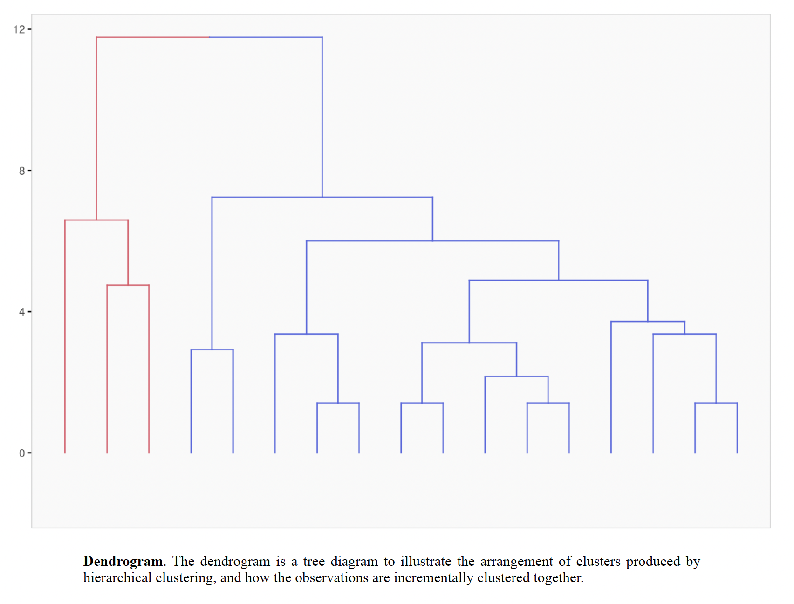

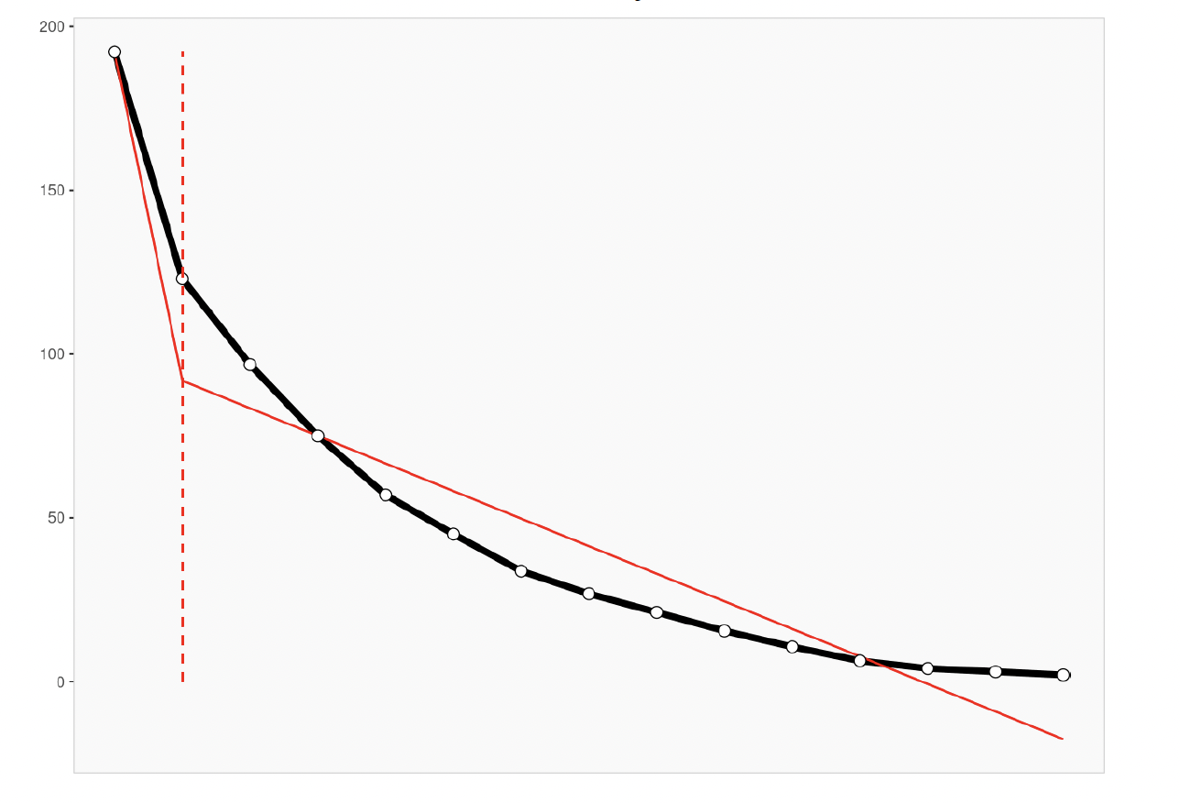

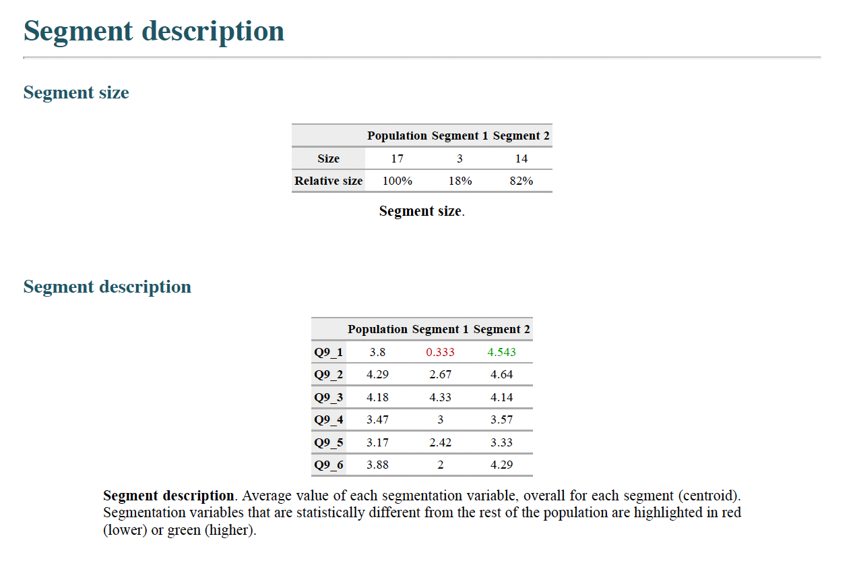

Visual outputs indicate a clear “elbow” after two clusters, confirming that a 2-cluster model effectively captures the underlying structure of the market.

Segment Profiles

Segment 1 – Low-Engagement Traditionalists (18%)
- View coffee as functional rather than emotional or social.
- Lower engagement across most attitudinal factors, particularly personalization and social sharing.
- Likely occasional or price-sensitive buyers who visit less frequently.
Marketing Implication: This group is a secondary focus. Efforts can emphasize convenience, speed, and value promotions to encourage more frequent visits.

Segment 2 – Brand-Engaged Loyalists (82%)
- Coffee is a key part of daily life and brand experience.
- High on all positive attitudes: fun culture, community spirit, and personalized service.
- Visit frequently, spend more per trip, and actively engage on social media.
Marketing Implication: Core customer base; ideal target for loyalty, community initiatives, and personalized engagement.

Segment | Target Strategy | Segment
Primary Target: Brand-Engaged Loyalists (82%) | Focus on loyalty-building and retention campaigns such as app-based rewards, personalized offers, and local community events. | Primary Target: Brand-Engaged Loyalists (82%)
Secondary Target: Low-Engagement Traditionalists (18%) | Use value-driven promotions (e.g., drive-thru discounts, limited-time offers) to increase visit frequency and brand familiarity. | Secondary Target: Low-Engagement Traditionalists (18%)

Descriptor Analysis
Purpose:
Descriptor analysis helps explain how the two identified segments differ in observable and actionable ways — based on behavioral, demographic, and psychographic variables.
While the segmentation itself was derived from attitudinal variables (Q9_1–Q9_6), this step focuses on who the customers are and how they interact with Dutch Bros in real life.

Descriptor Variable | Segment 1 – Low-Engagement Traditionalists (18%) | Segment 2 – Brand-Engaged Loyalists (82%) | Interpretation
Drink Type (Q6) | Prefer hot or traditional coffee options. | Favor iced and blended drinks, core to Dutch Bros’ product line. | Segment 2 aligns closely with Dutch Bros’ fun, flavor-oriented brand identity.
Purchase Method (Q8) | More likely to order in person or walk-up. | Heavily use drive-thru, mobile app, and fast service channels. | Loyalists value convenience and accessibility.
Age (Q15) | Primarily 18–24-year-olds. | Mix of 25–34 and early professionals. | Both young, but Segment 2 represents slightly older, stable repeat buyers.
Gender (Q16) | Predominantly female. | Female-skewed but more balanced gender mix. | Brand attracts strong female base, but Segment 2 shows broader reach.
Lifestyle (Q23) | Adventurous, creative, relaxed. | Social, busy, health-conscious. | Loyalists live faster-paced, community-oriented lifestyles.
Visit Frequency | Visit occasionally (avg. = 1.0). | Visit regularly (avg. = 1.5). | Frequency is a major behavioral discriminator.
Spending Level | Lower spending per visit. | Higher spending and willingness to try premium drinks. | Indicates stronger brand commitment in Segment 2.
Motivation Type | Driven by convenience or habit. | Motivated by brand vibe, personalization, and social energy. | Segment 2 engages for emotional and experiential reasons.

Key Insights
- Segment 2 – Brand-Engaged Loyalists are younger professionals who are socially active, higher-spending, and frequent users of drive-thru or app-based ordering.
They are deeply aligned with Dutch Bros’ brand values — energy, community, and friendliness — and represent the company’s core target market.
- Segment 1 – Low-Engagement Traditionalists consist of lower-frequency, functional coffee drinkers with minimal emotional attachment.
While smaller in size, this group offers a growth opportunity through convenience-oriented promotions and introductory offers.

🏗️ Theoretical Model

Theoretical Model for Dutch Bros Coffee Market Segmentation Study

1. Research Objective
To identify and profile distinct market segments among Dutch Bros Coffee consumers based on their demographic, psychographic, behavioral, and perceptual characteristics — in order to support targeted marketing strategies, brand positioning, and customer retention initiatives.

2. Conceptual Foundation
The model integrates three established marketing and consumer behavior theories:
- Consumer Behavior Theory (Engel, Blackwell, & Miniard, 1995)
→ Explains how attitudes, motivations, and lifestyle influence purchasing behavior.
- Segmentation–Targeting–Positioning (STP) Framework (Kotler & Keller, 2016)
→ Guides the identification of distinct consumer groups based on measurable differences.
- Brand Personality and Relationship Theory (Aaker, 1997; Fournier, 1998)
→ Justifies inclusion of attitudinal and emotional connection items (e.g., "fun, friendly culture").

3. Key Constructs and Variables
Construct / Dimension | Measurement Variables (from questionnaire) | Purpose / Rationale
A. Demographic Segmentation | Age, gender, education, income, zip code | Identify socio-economic and geographic patterns influencing coffee consumption.
B. Behavioral Segmentation | Frequency of visits, average spend, beverage type, purchase channel, time of visit | Capture observable buying patterns and usage occasions.
C. Psychographic Segmentation | Lifestyle descriptors, values (e.g., social, fun, creative), attitude toward brand personality | Identify underlying motivations and self-concept associations with the brand.
D. Brand Perception & Satisfaction | Brand satisfaction, perceived service quality, brand loyalty, NPS score | Reflects affective and evaluative dimensions of customer experience.
E. Motivation / Benefit Sought | Primary reason for visiting (taste, service, convenience, vibe, etc.) | Explains the “why” behind behavior — a critical segmentation basis.
F. Purchase Context / Situation | Time of day, product type | Contextualizes consumption in lifestyle routines and habits.

4. Theoretical Model Diagram (Conceptual Relationships)
Demographics ─┐
├──► Behavioral Patterns ──► Segment Profiles
Psychographics ─┘ │
▼
Brand Perception & Satisfaction
│
▼
Loyalty & Word-of-Mouth Intentions

Interpretation:
- Demographic and psychographic traits influence behavioral patterns.
- Behavioral patterns define the segments (e.g., “Daily Drive-Thru Loyalists,” “Social Flavor Seekers”).
- Perceived brand image and satisfaction mediate loyalty and advocacy outcomes.

5. Analytical Model (Quantitative Framework)

Stage 1 – Data Reduction
Use Factor Analysis (FA) on:
- Psychographic and attitudinal statements (Q9)
- Brand perception items (Q11–Q13)
→ Identify latent constructs such as:
- Community & Connection
- Fun & Energy Orientation
- Convenience Seeking
- Price Sensitivity

Stage 2 – Segmentation
Perform Cluster Analysis (K-Means or Hierarchical) using:
- Factor scores (from FA)
- Key behavioral variables (visit frequency, spend, product preference)
- Optional demographics (age, income) as descriptive attributes
→ Identify 3–5 homogeneous segments.

Stage 3 – Profiling and Validation
- Use Cross-tabulations and ANOVA to compare clusters by demographics, satisfaction, and loyalty scores.
- Profile each cluster’s defining attributes and label them (e.g., “The Loyal Regulars,” “Trend-Seeking Students,” “Occasional Treat Seekers”).

6. Expected Segments (Illustrative Examples)
Segment Name | Key Traits | Marketing Implications
Drive-Thru Regulars | Visit daily, loyal to convenience and service | Focus on speed, rewards, and app ordering.
Flavor Seekers | Prefer unique or seasonal drinks, social media users | Emphasize creativity, limited editions, influencer content.
Community Fans | Motivated by friendly baristas and social vibe | Highlight brand culture, local events, and community giving.
Budget-Conscious Students | Price-sensitive, enjoy social visits | Offer promotions, loyalty discounts, group bundles.

7. Theoretical Proposition Summary
Proposition | Description
P1: Psychographic traits significantly predict behavioral segmentation variables. | (e.g., energetic/fun seekers visit more frequently.)
P2: Brand satisfaction mediates the relationship between psychographics and loyalty intentions. | (Positive brand experience reinforces segment loyalty.)
P3: Demographic and situational variables moderate the strength of these relationships. | (Income, age, and time of day influence purchase frequency.)

8. Application in Marketing Strategy
The model allows Dutch Bros to:
- Identify high-value customer segments for retention campaigns.
- Tailor communication based on psychographic resonance (fun, community, energy).
- Optimize menu, pricing, and location strategies per behavioral cluster.
- Align brand positioning with segment-driven insights.

Dutch Bros Coffee Segmentation Study – Variable Framework

1. Unit of Analysis
Individual consumer (Dutch Bros customer or potential customer)
Each survey respondent represents one unit of analysis, since the study examines individual-level differences in consumption behavior, attitudes, and demographics.

2. Independent Variables (Predictors)
These are the factors hypothesized to influence consumer behavior and segment membership. They include demographic, psychographic, and motivational variables.
Category | Variable | Measurement Type | Theoretical Rationale
Demographic | Age, Gender, Education, Income, Employment status, Zip code | Categorical / Ordinal | Used to describe market structure and potential moderating effects on behavior.
Psychographic / Attitudinal | Agreement with statements about lifestyle, values, brand personality, community orientation (Q9) | 5-point Likert | Reflect personality traits and brand-related values influencing buying patterns.
Motivational / Benefit Sought | Primary reason for visiting Dutch Bros (taste, convenience, vibe, etc.) | Nominal | Captures intrinsic and extrinsic motivations behind brand choice.
Lifestyle Descriptors | Self-identification (e.g., health-conscious, adventurous, social, etc.) | Multiple response nominal | Used for psychographic segmentation and cluster profiling.
→ Conceptually:
These variables drive or predict customers’ observable behaviors (visitation, spending, product choice).

3. Dependent Variables (Outcomes)
These reflect behaviors and attitudinal outcomes influenced by the independent variables.
Category | Variable | Measurement Type | Interpretation
Behavioral | Frequency of visit, Purchase channel, Time of visit, Average spend, Type of beverage purchased | Ordinal / Nominal | Observable consumption patterns that define clusters/segments.
Brand Perception / Satisfaction | Overall satisfaction, perceived service quality, NPS (likelihood to recommend) | Interval (1–5 or 0–10 scale) | Affective outcomes reflecting consumer evaluation of the brand.
Loyalty Intention | Intention to repurchase or recommend (NPS) | Continuous | Behavioral intention resulting from satisfaction and perception.
Segment Membership (derived variable) | Cluster assignment (from cluster analysis) | Nominal | Outcome grouping derived from patterns in behavior and attitudes.
→ Conceptually:
Independent variables explain why and how consumers differ across these outcome patterns.

4. Control Variables
Control variables are factors that may influence the dependent variables but are not central to the study’s hypotheses; they are statistically controlled to isolate effects.
Variable | Reason for Control
Region / Zip code | Geographic variation in access to Dutch Bros locations can affect visit frequency.
Length of customer relationship (tenure) | Longer-term customers may show higher satisfaction or loyalty regardless of psychographics.
Time of data collection (day/time) | Behavioral patterns can fluctuate by season, time of day, or promotion cycles.
Competing brand usage (e.g., Starbucks) | Prior brand preferences may bias perceptions of Dutch Bros.
→ Conceptually:
These ensure that the observed relationships between psychographics, behavior, and satisfaction are not confounded by external contextual factors.

5. Summary Table
Variable Type | Examples | Measurement Scale | Used For
Independent | Age, Income, Lifestyle, Attitude toward brand, Motivation | Nominal / Ordinal / Likert | Predict segment membership & satisfaction
Dependent | Frequency of visit, Average spend, Brand satisfaction, Loyalty (NPS) | Ordinal / Interval | Define behavior and attitudinal outcomes
Control | Zip code, Tenure, Competing brand use | Nominal / Ordinal | Statistically hold constant
Unit of Analysis | Individual coffee consumer | — | Level of observation and data collection

6. Example Hypothetical Relationships
Hypothesis Example | IV | DV | Control
H1: Customers who value fun and energetic brand culture visit Dutch Bros more frequently. | Psychographic value (fun & energy) | Visit frequency | Zip code
H2: Community-oriented values increase brand satisfaction. | Psychographic “community” factor | Brand satisfaction | Tenure
H3: Younger customers spend more on blended and energy drinks. | Age | Product type / Spend per visit | Gender
H4: Satisfaction mediates the effect of psychographic fit on loyalty intention. | Psychographic fit | Loyalty intention | Brand tenure, competing brand usage

